The Directed Acyclic Graph results establishes contemporaneous causal relationships between some key properties of the studies included in the meta-analysis, which will be useful in establishing or fitting a model for subsequent econometric analysis. The study examined the effect that these properties have on the outcomes of the studies that were conducted. The various funding sources, the organization type they support, and the results of studies on the impact of glyphosate and their relationship were examined. First, we sought to examine the relationship between funding source, affiliation and outcome from the three sources of funding and affiliation: public, private and university funding; public, private and university affiliation.

**Public Funding, Public Affiliation, General Outcome**

Figure 1: Public Funding, Public Affiliation, General Outcome

The initial model comprised of public funding, public affiliation and outcome. From the graph produced, public organizations had a positive causal relationship with public funding which in turn caused the outcome of glyphosate research findings positively. Since public institutions were almost only funded by public funds by virtue of state budgetary allocation, public funding was caused (in this case provided) by the organization to investigate the impact of glyphosate. Hence the outcome of research studies by public institutions were linked by the funding provided by the state. From the DAG it can be inferred that publicly funded research conducted by public entities resulted in findings that concluded that glyphosate had harmful impact.

**Private Funding, Private Affiliation, General Outcome**

The DAG between Private Funding, Private Affiliation, and Outcome demonstrated that private funding positively affects private affiliation, which in turn has a negative effect on the outcome of the study. This can be interpreted as the link between private organizations and non-harmful glyphosate research findings was funding from private entities. From the DAG it can be concluded that privately funded research conducted by private entities resulted in findings that concluded that glyphosate had no harmful impact.

Figure 2: Private Funding, Private Affiliation, General Outcome

**University Funding, University Affiliation, General Outcome**

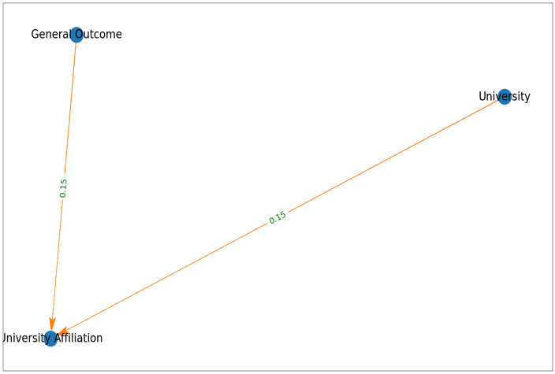

Figure 3: University Funding, University Affiliation, General Outcome

As part of their mission, universities and for that matter the ones identified in the meta-analysis are committed to research as a central part of their existence. It is common for university research to be funded by private, public and university funding. Due to this, we interacted university affiliation, outcome of research and the three sources of funding separately to observe the nature of the interaction. From the DAG results obtained, outcome of the study, university funding caused university affiliation. University funding only goes into university research conducted within the university which is illustrated from this finding. From the DAG, general outcomes which reported adverse effect of GBH were likely to come from university affiliated research.

**Public Affiliation, Private Affiliation, University Affiliation, General Outcome**

The study went on to investigate the effect the various organizations had with general outcome. Private organizations did not have any relationship with any of the various as shown from the DAG.

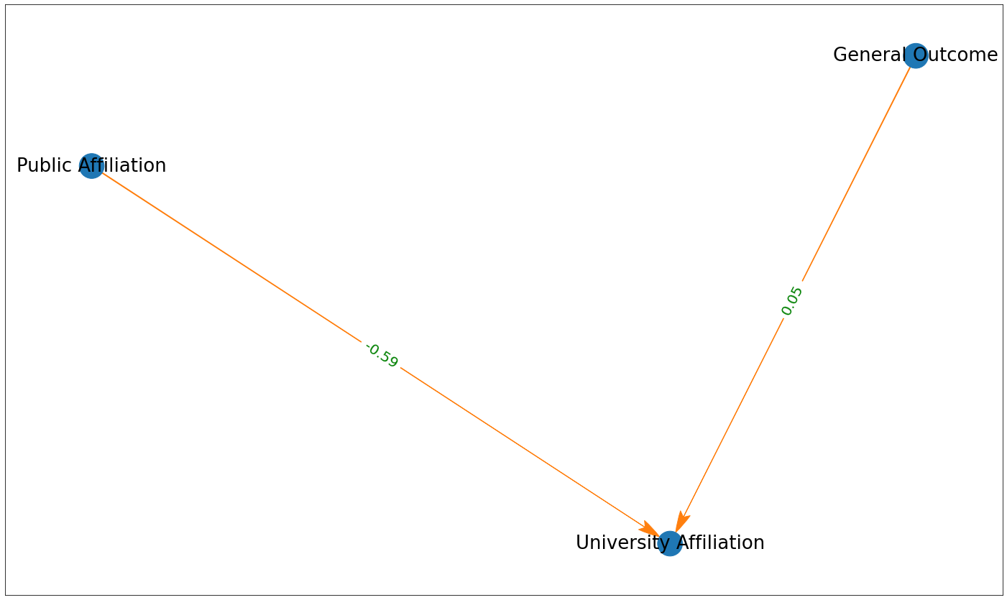

Figure 4: Public Affiliation, Private Affiliation, University Affiliation, General Outcome

Public and University affiliation had a negative relationship which could be explained as public institutions did not engage with university researchers to conduct GBH studies. In terms of the relationship between public and university, it is mainly a funding relationship, not researchers coming together to conduct studies. University researchers are given autonomy to conduct their own studies devoid of public interference. Also, from this DAG, it can infer that general outcomes which reported adverse effect of GBH were likely to come from university affiliated research.

**Public Funding, Private Funding, University Funding, General Outcome**

It is important to look into the effect the various funding sources had on the outcome of the studies into impact of glyphosate use on human, environment and other non-target organisms. From the DAG obtained from the interaction between public, private & university funding on the outcome of studies, only public funding and outcome had a significant causal relationship. Private and University funding had no significant causal relationship with public funding and outcome of studies. Public funding is said to be the main pillar of research which is regarded as a public good. The relationship identified in this study suggests that general outcome causes public funding positively. This could be interpreted as research indicating that glyphosate has adverse effect on the environment and non-target organisms leads to state allocating funds to further investigate the phenomenon as a public health concern.

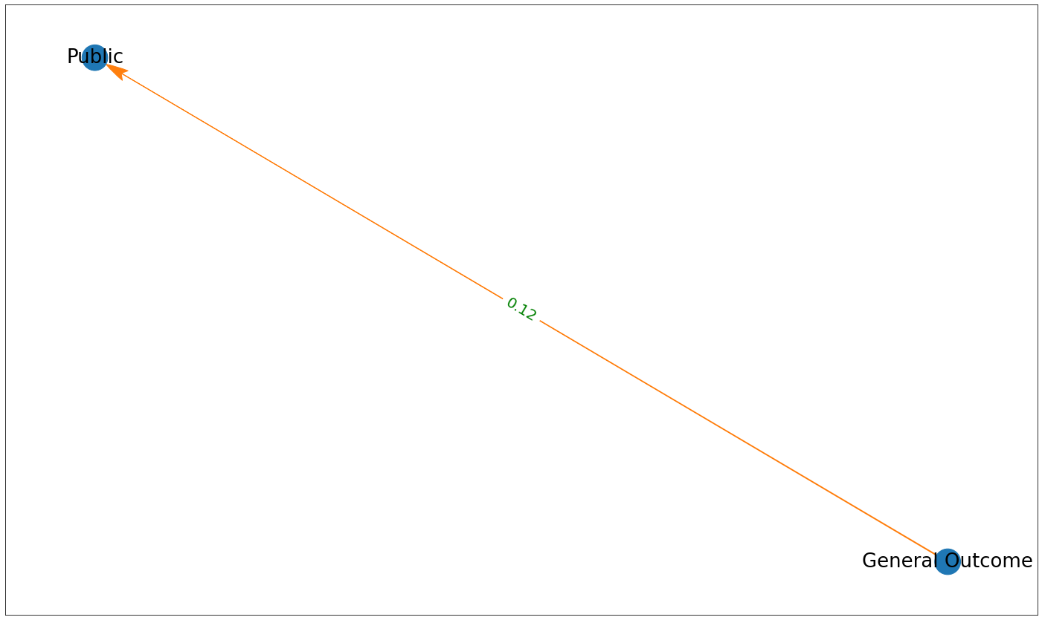

Figure 5: Public Funding, Private Funding, University Funding, General Outcome

**Public Funding, Public Affiliation, Private Funding, Private Affiliation, University Funding, University Affiliation, General Outcome**

The causal relationship between the author's affiliation (public, private, or university) and the source of funding for the research was investigated. The result of the DAG with the various authors' affiliation and funding sources considered for the meta-analysis, shown in Figure 1, indicates a positive causal relationship between private funding & private organizations, public funding & public organizations, and university funding & university affiliation. While cross-funding between funding sources and affiliations, particularly in the case of public funding to all other organizations, was expected, the DAG-identified relationship demonstrates the statistically significant causal relationships. All the causal relationships in this analysis were caused by funding sources. This means the various funding sources are likely to go to the organization types they cause.

Figure 6: Public Funding, Public Affiliation, Private Funding, Private Affiliation, University Funding, University Affiliation, General Outcome

